Chapter 9, Problem 77.

Refer to the RC circuit in Fig. 9.81.
(a) Calculate the phase shift at 2 MHz.
(b) Find the frequency where the phase shift is 45°.
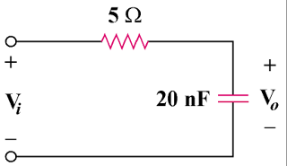

Figure 9.81
For Prob. 9.77.

